Permission Modification WebUI - Share Drawer Adaption SPX-5523: WebUI Permission Modification with Real Time Evaluation

WebUI Permission Modification UX PRD & Ticket Breakdown

Goal: Unify all permission modification and share flows with the UI experience of the New Share Drawer to provide real time evaluation and a similar user experience of initial sharing events through the WebUI Implemented in V1.

Description:

This effort will be require the creation of permission modification panes that supports the various modifications that a data owner can make within the WebUI including:
- Adding recipients to an existing file permission
- Viewing Existing Permissions
- Accessing file links
- Changing Existing Recipient Details
- Updating Policy
- Adding files to a folder
- Adding new recipients to a folder

Figma: This release will also require the removal of existing WebUI elements for permission/state modifications linked visually here. These include:
- Security Settings - “Change policy” & “who has access”
- Share selection buttons
- Edit Permissions button
- Activity right side popout & buttons included

This V2 element of PAR will begin with the creation of the new panes which are prompted from existing buttons without changing the overall design of the WebUI - just replacing old pop-outs for permission modification with the new panes. Later states of this release will update the My Files view for reconsidered overall appearance.

The Primary Entree Points of this implement are:
- New Share
- Permissions & Policy

Within these 2 entree points, the pane presentation must support the following variances:

- Adding a new recipient to an individual existing file
- Adding a new file to an existing folder
- Adding new recipients and new files to an existing folder
- Adding recipients to a policy with additional recipient detail – allowing addition and revision of all recipient detail
- Changing of policy that will affect all recipients

Consistent Logic of Block Actions:
- Block Actions are only presented when the block action affects existing provisioned recipients (1 or more recipients can’t access one or more files within an existing folder) OR block actions affecting recipients that the data owner is trying to add.
- Permission Modification Flows do not surface all recipients that have been blocked for the history of the file (this data is available via audit logs)

This Feature will also integrate new notification flows for the access revocation when forwarding policies are in place supporting the following scenarios:

Implement Existing “Permissions Review Pane” for a Single File - SPX-5575: Implement Existing “Permissions Review Pane” for a Single File
SPX-5525: Implement Existing Permissions Review Pane for Single File

Goal
Implement the open-state UI for reviewing and managing existing permissions and policy on an individual file.

Description
Create a standardized Permission & Policy Review Pane that surfaces:
- The currently applied policy
- All provisioned recipients
- Recipient roles and access state
- The active share link
This pane should mirror the presentation model used in Pane 2 of the New Share Drawer, but for existing shares. This pane becomes the primary surface for reviewing and modifying existing access.

Last version to Figma link of design.
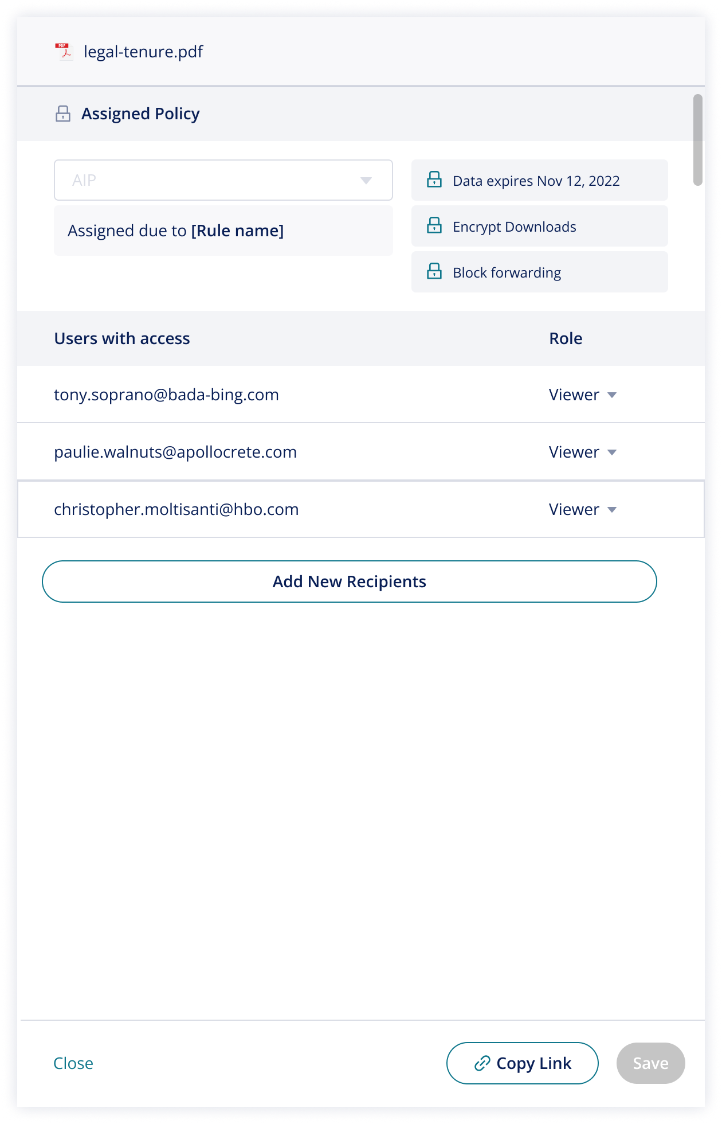
1. Pane Replacement Scope
This pane replaces:
- Existing permission review panes
- Existing “Who has access” pop-out
- Existing “Change policy” pop-out
- Existing right-side Activity pop-out (for permission review use case)
This pane becomes the single source of truth for the current permission state.
2. Policy Presentation
- Policy is displayed as Locked or Unlocked, following the New Share Drawer model.
- If the policy requires phone verification or password:
  - Recipients display their configured details.
  - Data Owner can modify recipient verification details directly in this pane.
3. Recipient Management & Access Revocation

Within this pane, the Data Owner can:
- Modify recipient role (Viewer ⇄ Contributor)
  - Role changes reflect immediately.
  - No PAR evaluation required.
- Remove recipients
  - Baseline behavior strikes through the recipient when access is revokes and footer buttons change to “discard changes” or “Apply Changes”
  - This may trigger instant Rule evaluation OR pop-ups so is detailed in an additional ticket
- Change Policy
  - This is also documented is a separate ticket when this occurs for this open state.
- Navigate to the pane for adding new recipients
  - This can only be done when existing changes made in the present pane are saved.
4. Support Long Recipient lists
This pane must also support review of long recipients - recipients should be presented alphabetically by email and page should open with scroll function when all recipients can’t be viewed in a single pane.
5. Support “Edit of Recipient Details” via linked pane
This pane should not allow the editing of existing password and phone number directly BUT it should provide a linked option to “edit recipient details” which provides a page to edit with larger fields and search function for specific user input. Changes must be manually applied and cannot be saved until fields are complete.

Implement Access Revocation Flows with Share-Drawer SPX-5602: Implement Access Revocation Flows with Share-Drawer

Goal: Implement Access Revocation Flows to provide clear user messaging for Rule Activation and Forwarding Policy considerations.

Description: Access revocation flows must be added to Share Drawer behavior to require explicit confirmation of “apply changes” AND populate any impact to policy state in the UI before changes are confirmed and applied to the backend.

Definition of done:
- Behavior follows mocks and behavior descriptions linked here in Figma.
- When “revoke” action is taken, the user whose permissions were removed is striked through and moves to the bottom of the recipient list. Only after “apply changes” is confirmed does the recipient name disappear completely.
- PGR evaluation is published as the recipient name is striked – this is not applied to the backend until changes are “applied”
- If user attempts to navigate away a pop-up message appears to require user to apply or discard changes.
- Revoking access may change policy assignment that now requires recipient that is missing.
- If revocation changed the policy, show the information icon next to “assigned policy”. This should only populate with a change to policy - not the unlocking of policy
- If details are missing, ONLY the missing details that are missing will display in this pane to be filled
- If the sender cannot complete these fields, the permission changes cannot be applied (this creates a possible stuck point for the sender and we should put guidance in the tool tip with Missing “Input the missing recipient detail or remove the recipient”

Implement Pop-Ups for Governance Messaging with Domain/Forwarding Policies SPX-5603: Implement Pop-Ups for Governance Messaging with Domain/Forwarding Policies

Goal: Implement Pop-Ups for Clear Governance Messaging alongside Share Drawer access revocation flows:

Description:
- UX follows mocks and behavior described here in Figma.
- Pop- Ups must support possible variants:
  - Domain forwarding policy when policy is unlocked
  - Domain forwarding policy when it is locked
  - Allow forwarding policy is unlocked
  - Allow forwarding policy is locked
- If Access is removed from a domain forwarding policy pop-ups may publish:
  - As presented here:
  - 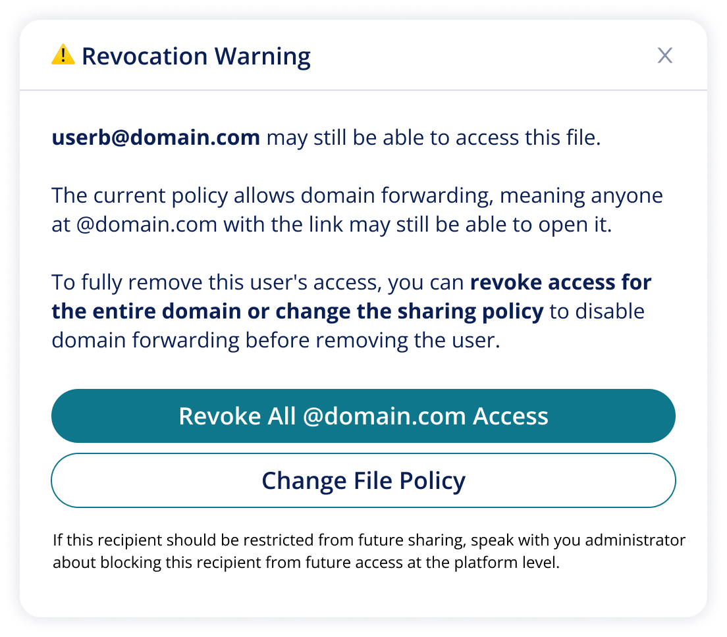
  - Pop-up only publishes when a user is being removed and there are other members of that domain with recipient permissions (meaning it does not populate every time a user is removed from a domain forwarding policy) AND policy is not locked.
  - If access is revoked from @domain, the pop-up publishes a confirmation which when closed leaves the user back at the permissions modification open state with changes applied.
  - If “Change File Policy” is clicked, the user pop-up closes with the permissions drawer still showing the recipient with the strike through off access revocation so the user can then change policy to non-forwarding and “apply changes” to remove the user.
- If the access revocation is attempted for an individual AND the policy is locked, this alternative pop-up publishes which does not suggest a change to policy:
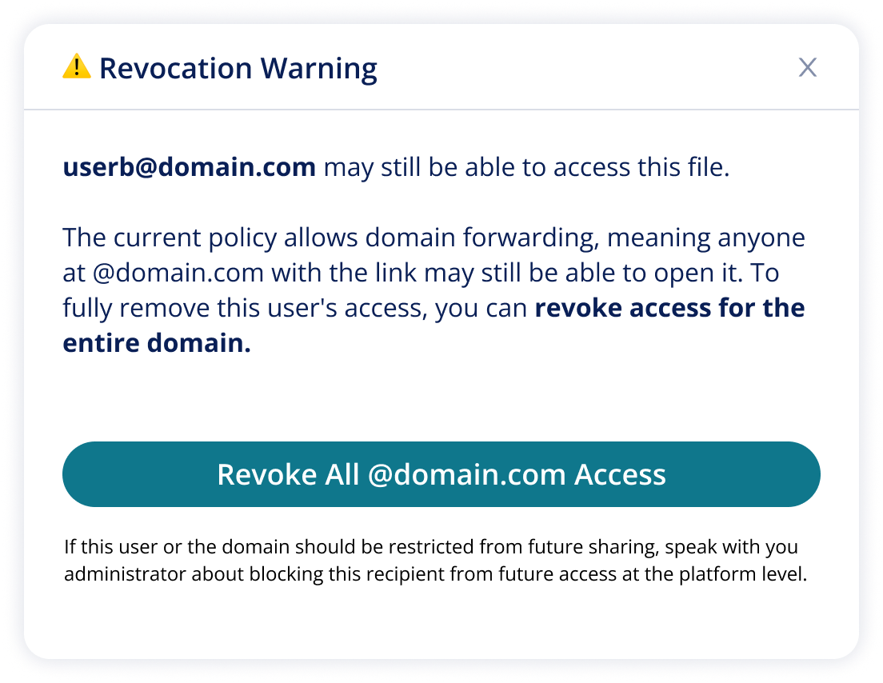
- Confirmation message should populate if this is clicked confirming that the entire domain was revoked. This should then close back to the updated recipient and policy view.
- If the access revocation is attempted for an individual when a forwarding policy is applied, populate this pop-up which allows the user change policy (recommended) or continue with access removal (which may be the valid option if the user hasn’t received the link yet.
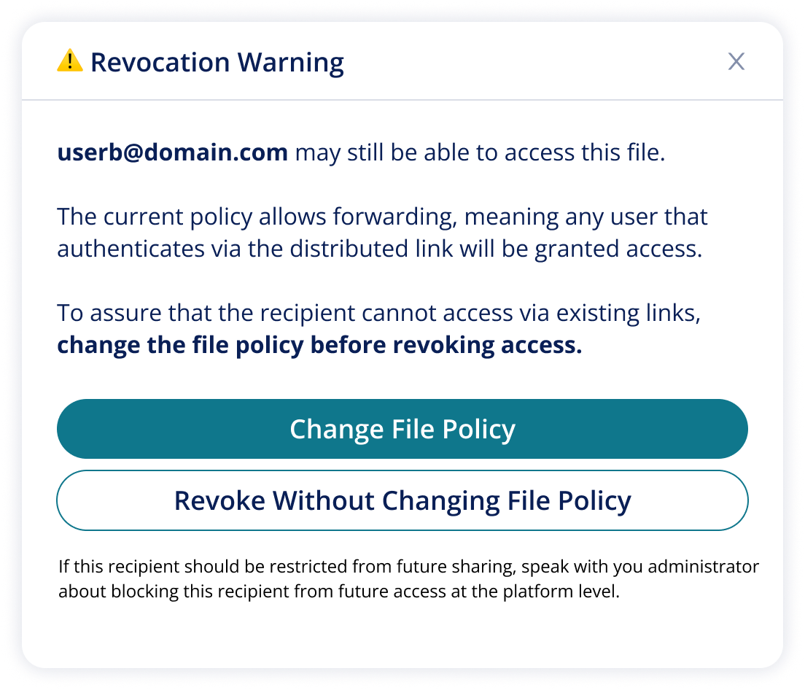
- If the access revocation is attempted for an individual when a forwarding policy is applied AND the policy is locked , populate this pop-up which allows the user change policy. The “change file policy” option should be greyed out, include a lock icon and not be clickable.
  - 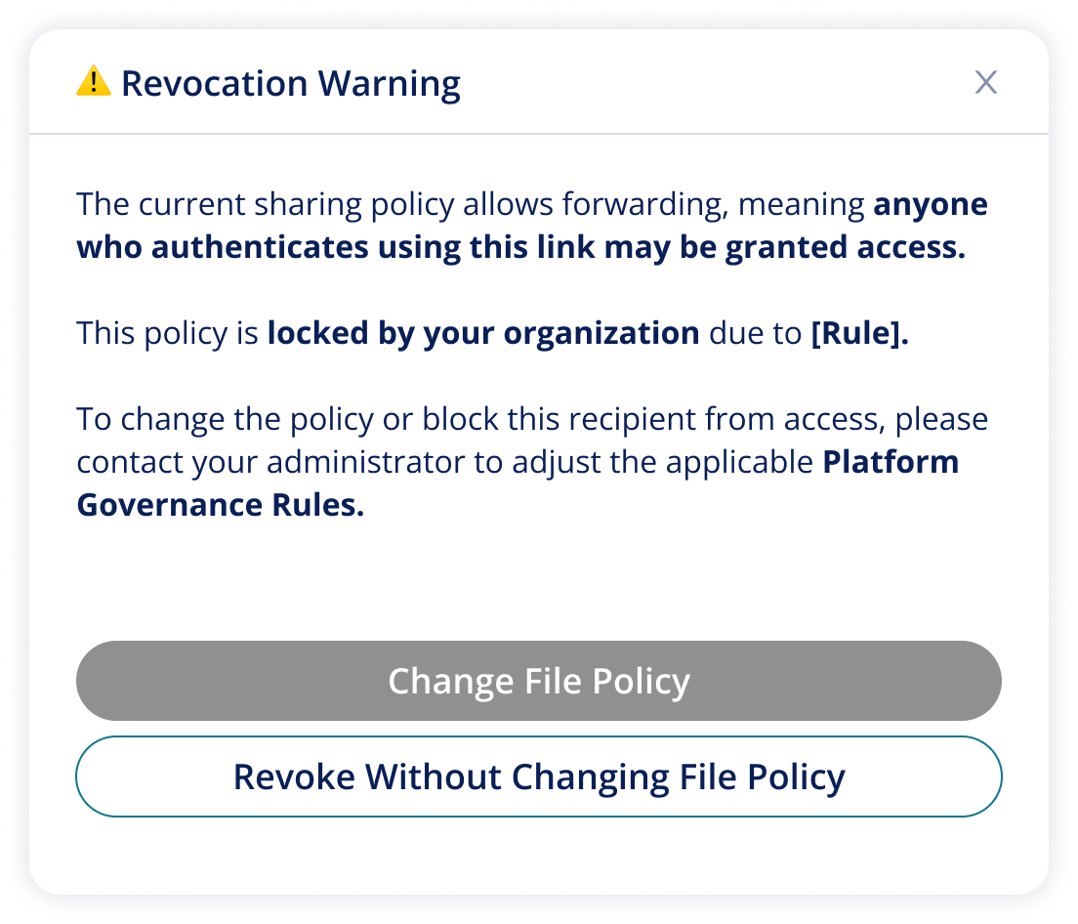

Implement Permissions Drawer for New Shares of an Existing File SPX-5604: Implement Drawer for New Recipient added to an Existing File

Goal: Implement an addition of the Drawer for sharing of existing files that shows clear visual indication of existing recipient permissions.

Description: When sharing an existing file we want to make sure the user takes note of the existing recipients that have access provisioned which is an industry standard.

https://www.figma.com/design/IdWYqlYlF04i3m97LjYChH/Loren-s-Work-Zone?node-id=2248-27046&t=kay19LcmtOOSNKTH-4 That will present the existing provisioned recipients in small icons as shown below: (Mock is awaiting this update)

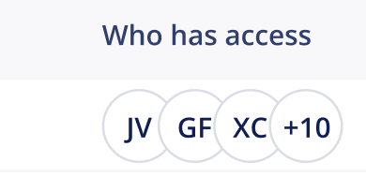
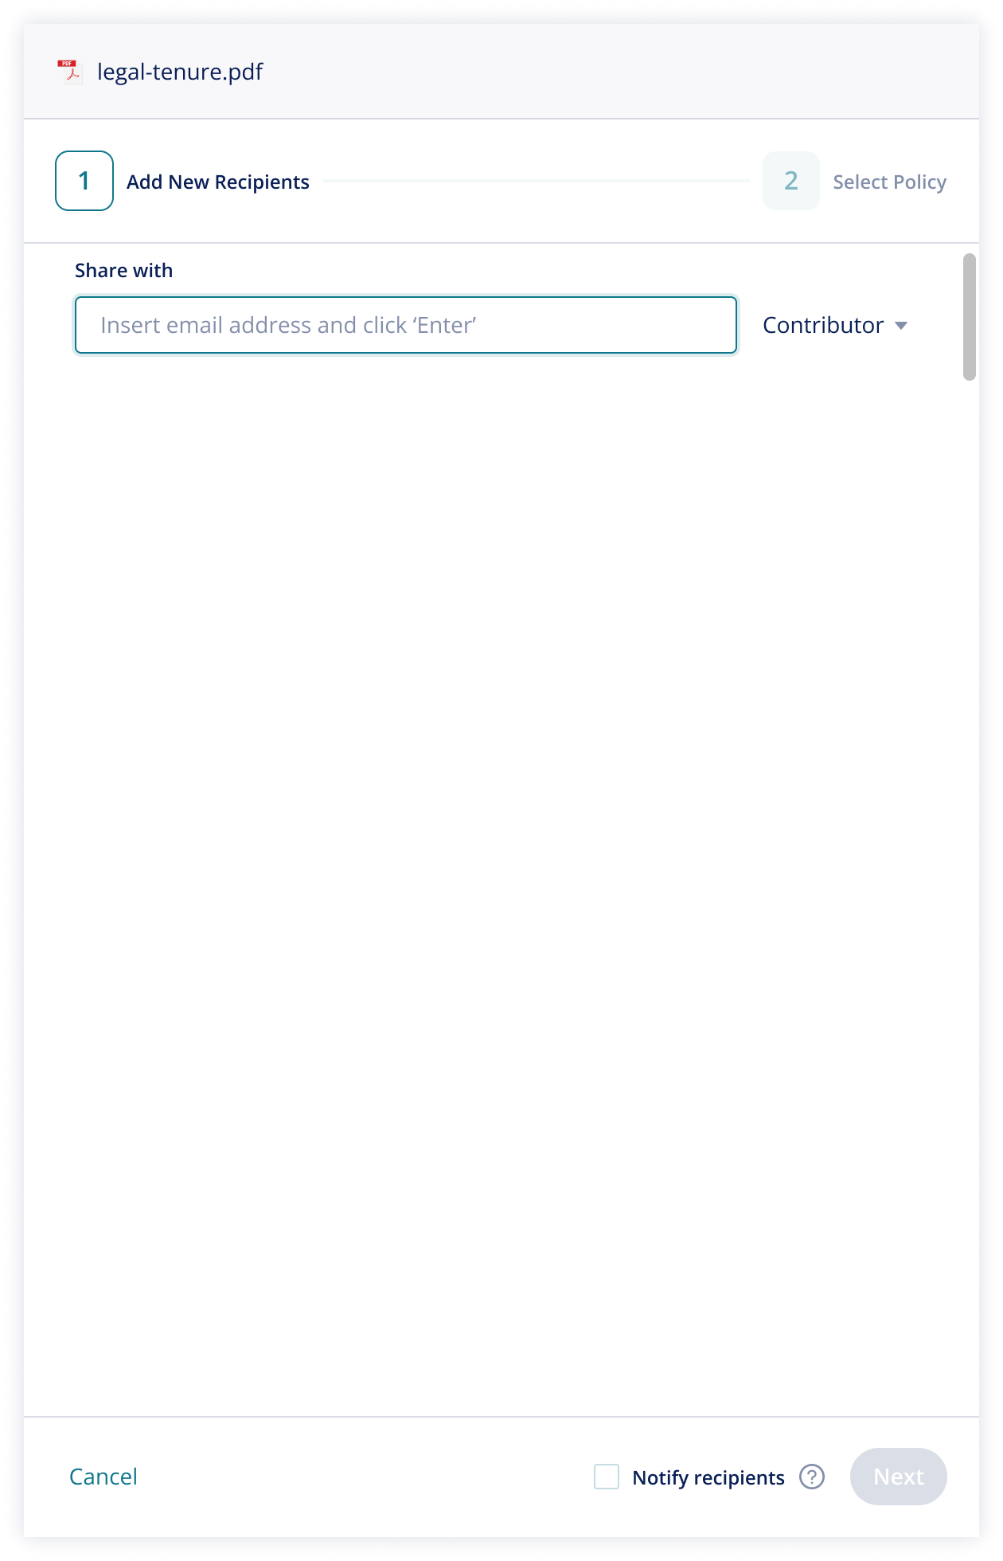

If this pane is opened and the user has not inputted a new recipient's detail, the button showing “cancel” presents as “Review Existing Permission” which would revert the view back to the Permissions drawer described in the ticket above. As soon as the user begins typing new recipient detail, the button changes to "Cancel"

Implement Drawer for Review of Exiting Folder Permissions SPX-5605: Implement Drawer for Review of Exiting Folder Permissions
Goal: Allow drawer to function for review of existing folder permissions, bringing attention to impact of rules for policy and recipients blocked from partial folder content.

Definition of done:
- Behavior aligns to mocks linked here and behavior notes.
- When a folder is opened, the policy assignment specifics the “Choose Parent Policy”
- Changing policy and/or revoking follows the same logic as when these changes are made to the permissions of a singular existing file (policy change and access revocation must be confirmed with “apply changes” or “discard changes”
- When some files of the folder have PAR assigned policy, this populates below just like new share flows.
- Note:
- Blocked users only populate when reviewing existing permissions when it is a recipient that has partial access to the folder
- users that were previously blocked from the entire folder do not show here.
- Blocked users are listed individually and specify which files they are blocked from. If they are blocked from more than 2 files, summarize as “& # others”
- 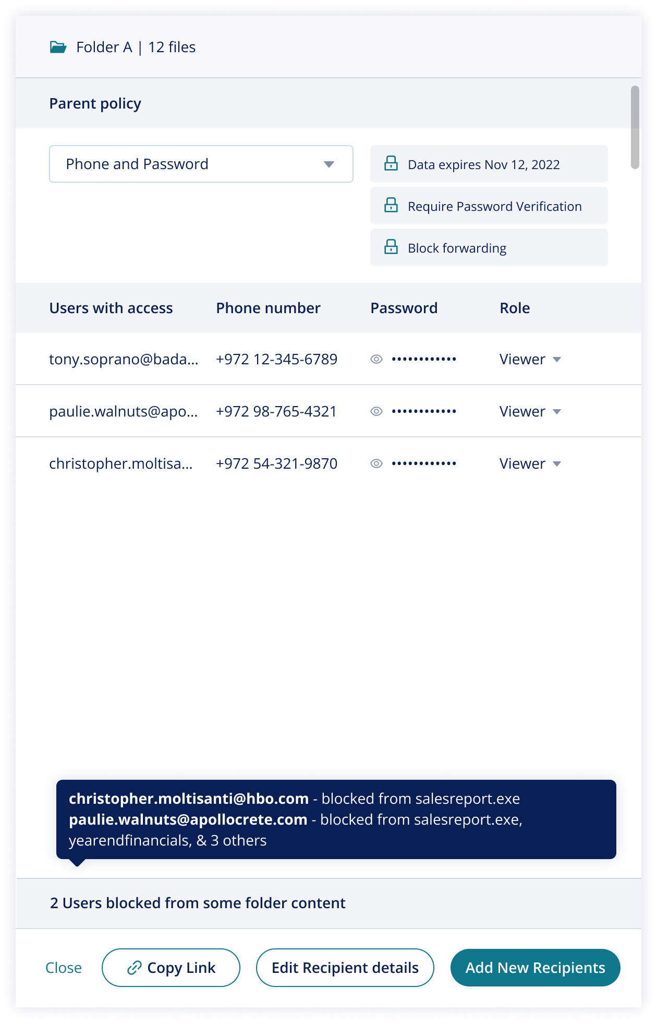

Update Block Action presentation in Existing Share Drawer Panes SPX-5618: Update Block Presentation in Upload flows to match V20 design across modification flows.

Goal: Update the V19 presentation of block result with the updated presentation of V20.

Description:

This version release updates the presentation of blocked results. In V19 blocked results were shown in 2 sections which duplicates information and complicates the UI. This release updates the presentation of blocked results to align with V20 style for Pane 2 Rule evaluation results for both share modification flows and upload flows created in V19.
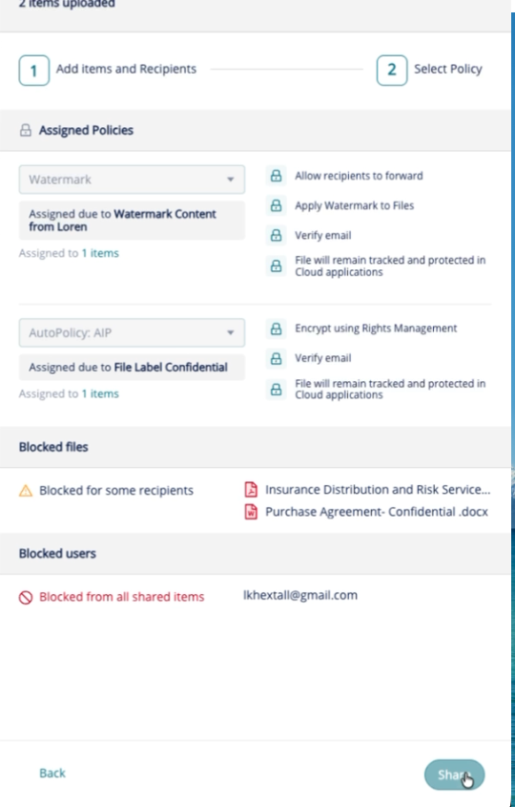

In V20, Blocked Recipients are listed individually, with recipients that were blocked from all files listed above recipients that were only blocked from some files of the share. Hovering over the recipient name and block icon will act as a tool tip that shows because of what Rule.

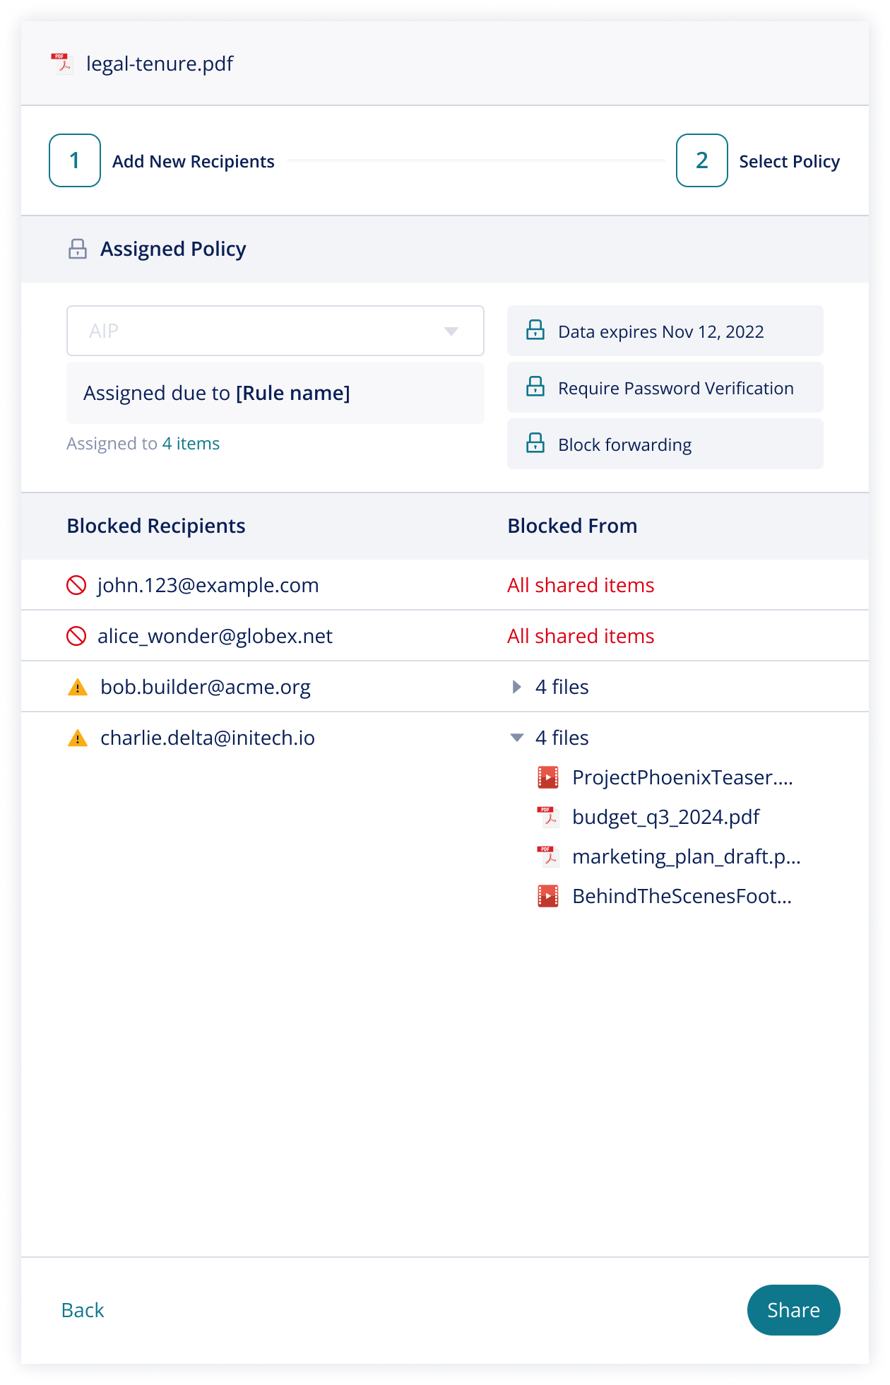

This update of V20 also updates the presentation of block results in post share message “Shared Successfully”. In V19 caution markers were shown next to files that had been entirely blocked for some recipients.

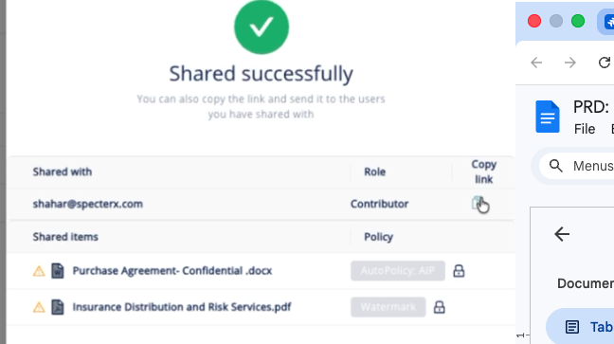

In V20, block icons are not used to show which a recipient has been blocked from a file entirely. Instead, block results are summarized only in the footer, publishing a list of blocked recipients from the last share listing up 3 files by name as shown below.

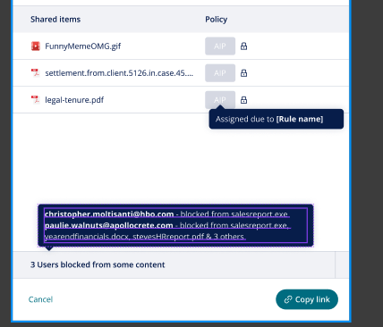

Support Adding New Items or Recipients to Folder
Follows this mock flow

Goal: Allow real-time evaluation through the share drawer when new recipients and/or files are added to a folder.

Description: Folder within SpecterX must support the ability to add recipients and new files to existing folders while allowing the data owner to understand Rule Evaluation consequences that may restrict the addition of new recipients or files and could also influence the access of existing recipients. This new flow provides clear UX experience that clearly show the data owner the impact of the changes that they have made to the folder with the addition of new recipients and/or files.

Starting point Open State:
When the “Share” operation is clicked for an existing folder OR a folder is opened and the “+ Add Files” button is clicked , the following pane view opens:

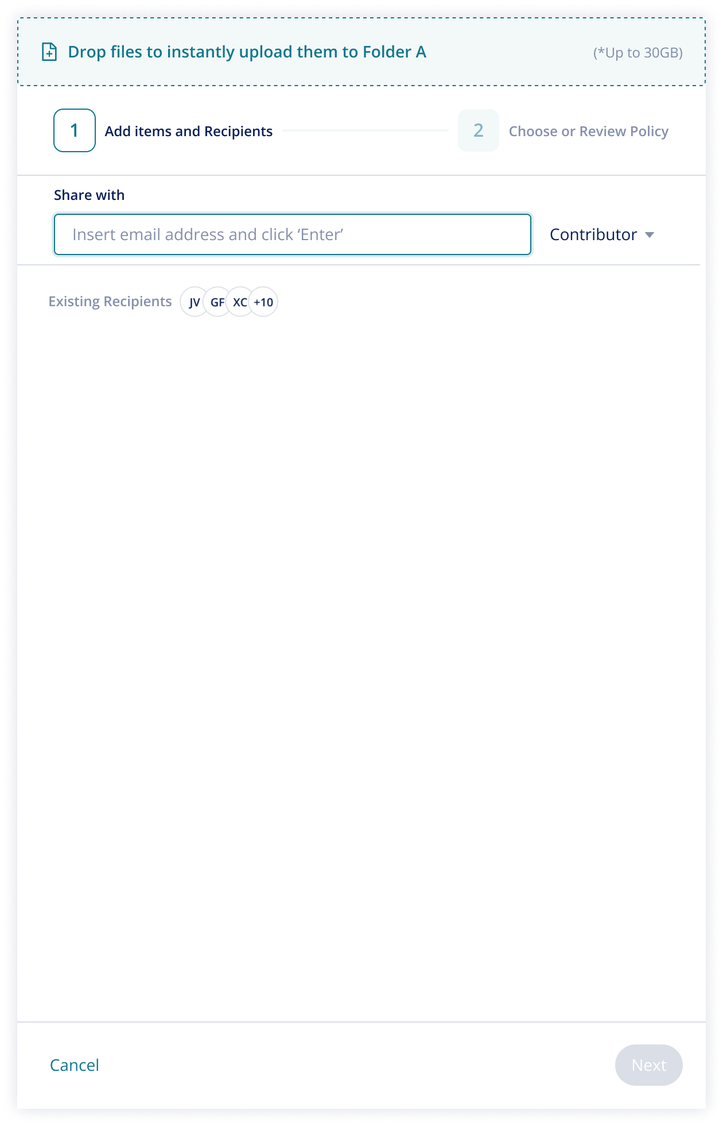

Note this Open state allows:
- A new recipient to be added, beginning the evaluation flow
- An entree point to review existing permissions which switches the pane view for Reviewing the Existing Permissions of a Folder
- New files to be added through drag and drop header

If no existing recipient access is provisioned, “no existing recipients” replaces recipient icons.

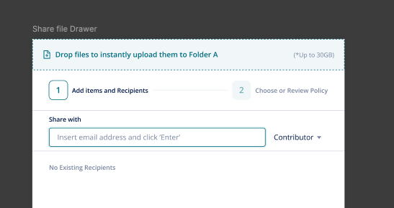

Flow: New Recipients added to a Folder

When new recipients are added to a folder, the pane view changes to reflect this action:

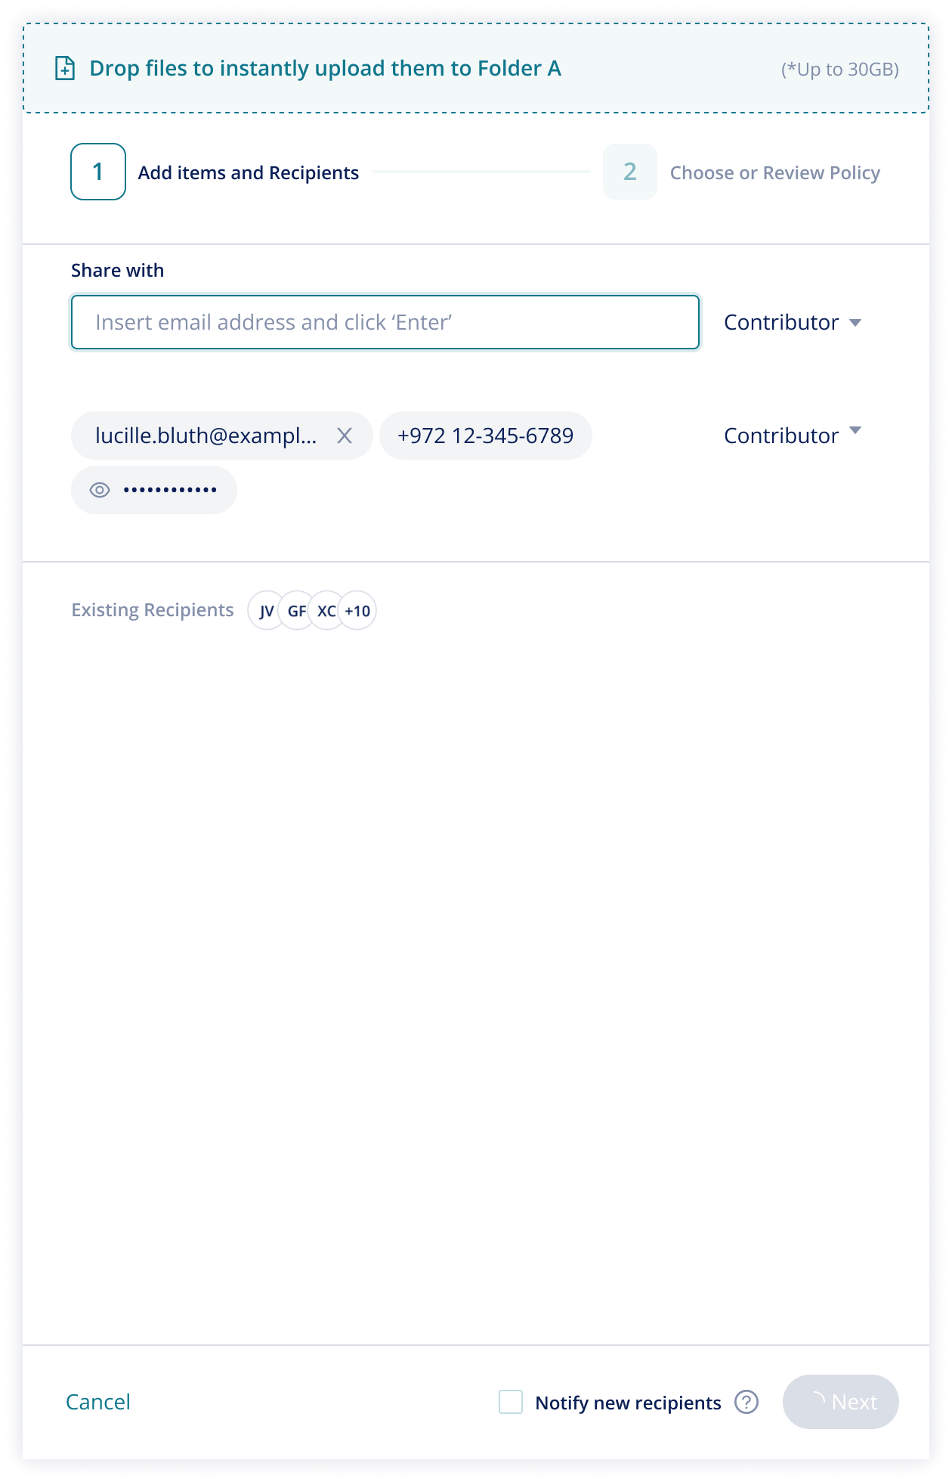

As new recipients are added:
- the next button shows the loading state until at least 1 new recipient has been added and then publishes in teal for a call to action to complete share by clicking “next” to progress
- “Notify new recipients” box publishes in the footer, directing the user that they may notify new recipients automatically
- The existing recipient icons are no longer clickable (as we want to force the user to complete the addition of new recipients that was initiated before navigating to a new pane view)

After the user has added new recipients and clicks “next”, the drawer progresses to the next pane for policy and Rule impact review.

If there has been no rules triggered the page presents as shown below:

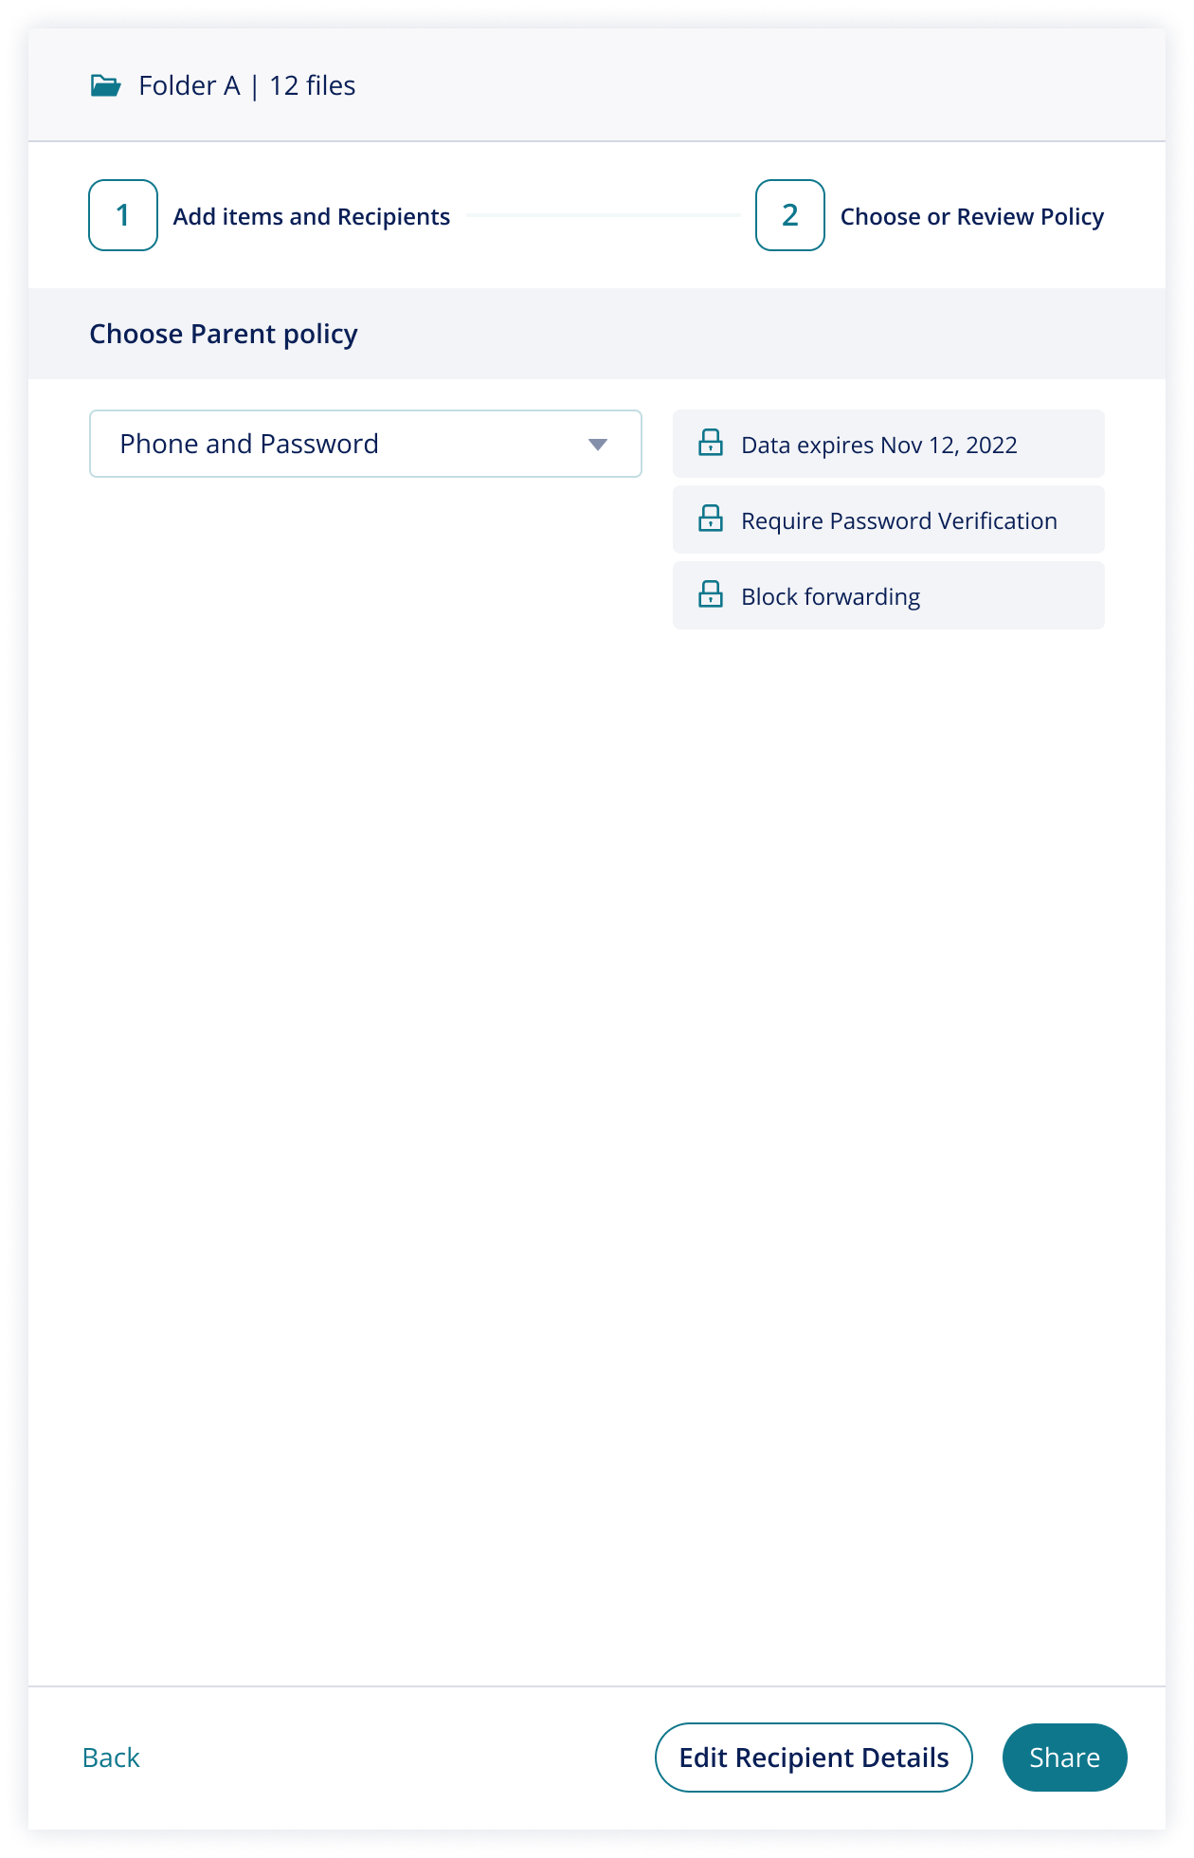

Note:
- When this pane publishes, the header is no long available for drag and drop for more file additions.
- If the policy assigned requires phone number and/or password and no details are missing from recipients, existing details are NOT shown below policy BUT existing details can be reviewed and edited via “edit recipient details” button in the footer.
  - If the policy does not contain phone number or password, this footer button is not published.
- To complete the share, the user must click “Share” and, like all panes, if the user tries to navigate away before completing the actions they have initiatives, a popup appears to force the user to save or discard changes

Once the user has clicked to “share” with the new recipient, the “Shared Successfully” pane publishes as shown below:

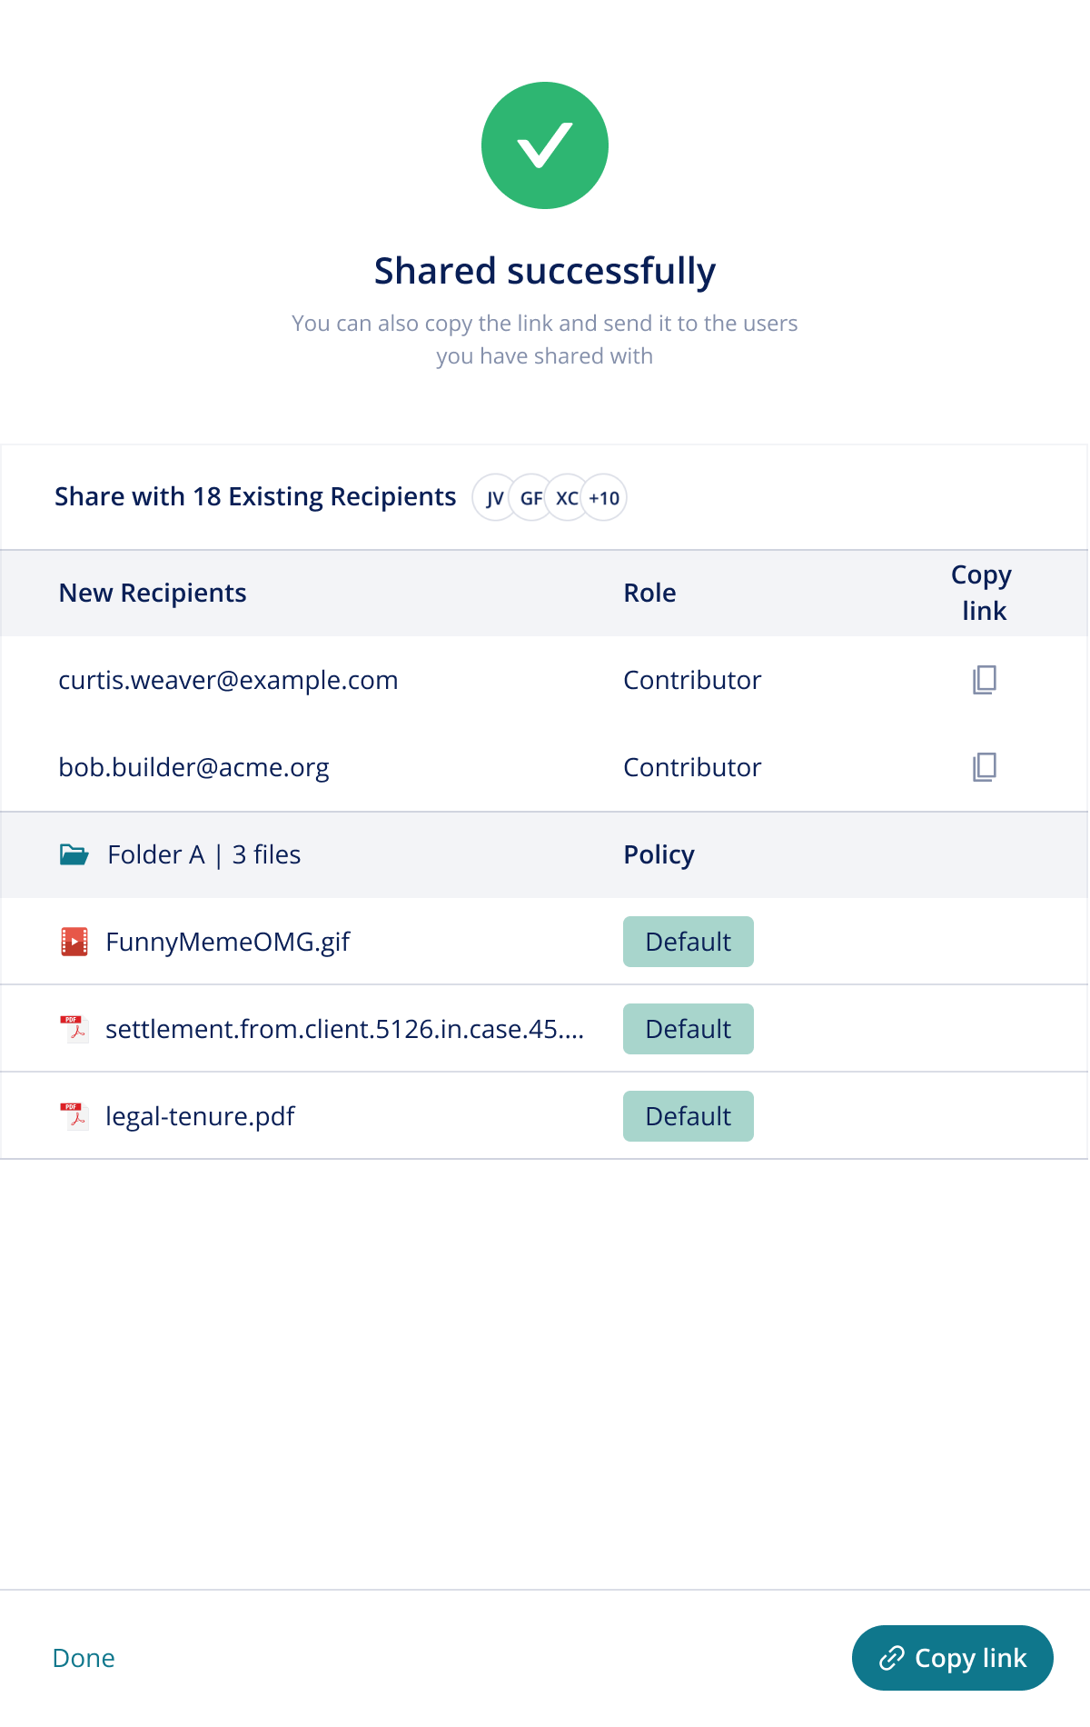

Note:
- Existing recipients are listed in above new recipients and summarized with Icons – this section is clickable, just as it was in the open state, navigating the user to the existing recipient permissions pane
- Only new recipients added in this share are listed individually, with individual access links to the right
- The Folder is shown with its name and the number of files within the folder AND lists each file within the folder
- “Copy link” in footer is non-user specific link to the folder

If the addition of new recipients does trigger rules, this is presented in the panes as shown/described below:

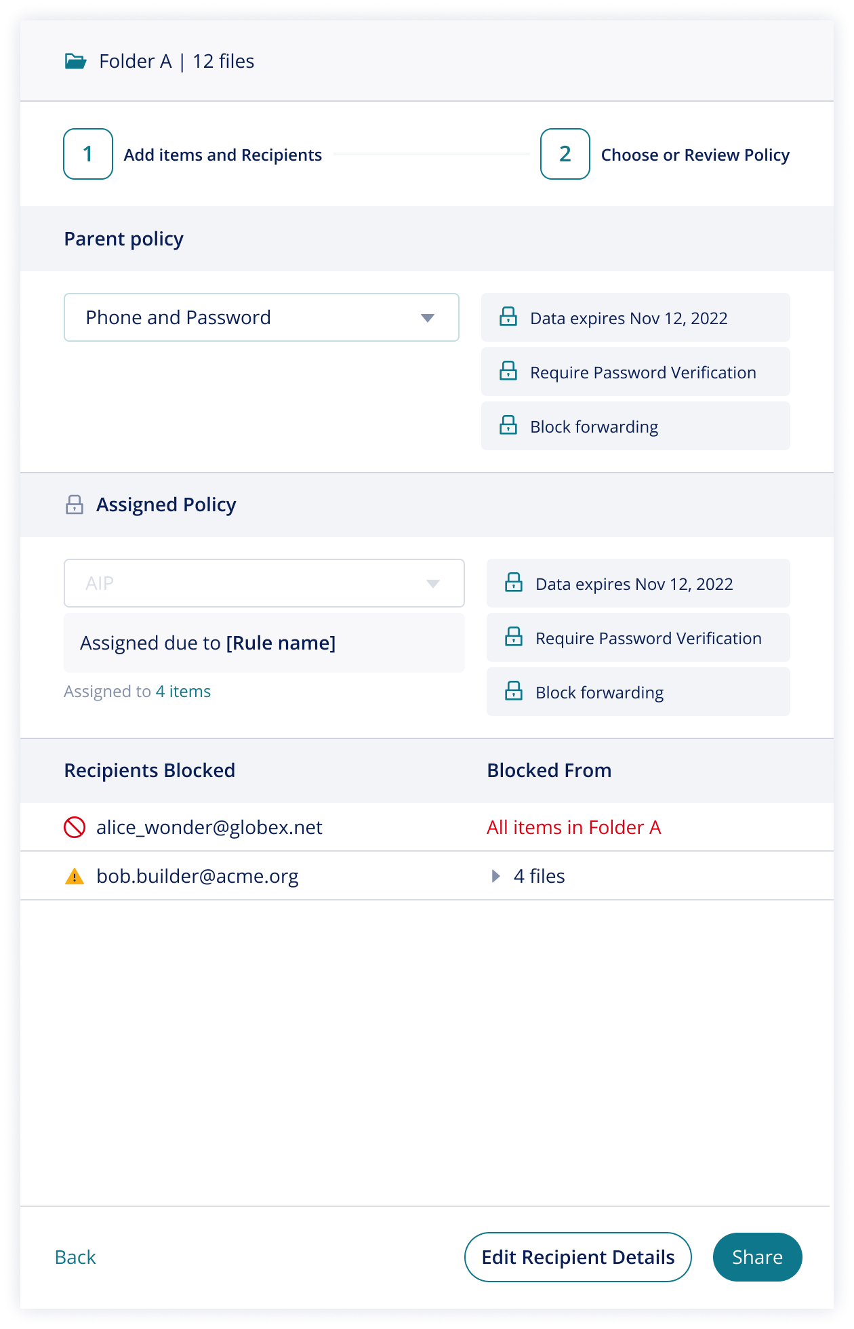

Note:
- Block results ONLY show results that were a result of the addition of the new recipient – they do not show users that were entirely blocked from the folder as a result of a previous share
- Pane shows the user can choose the Parent policy – and is explicit that this is the PARENT assignment
- If rules trigger assignment to specific files, pane shows this for the specific files

When the user clicks to complete the share by clicking “Share” in the footer, the “Shared Successfully pane” publishes as a summary of the shared state as shown below:

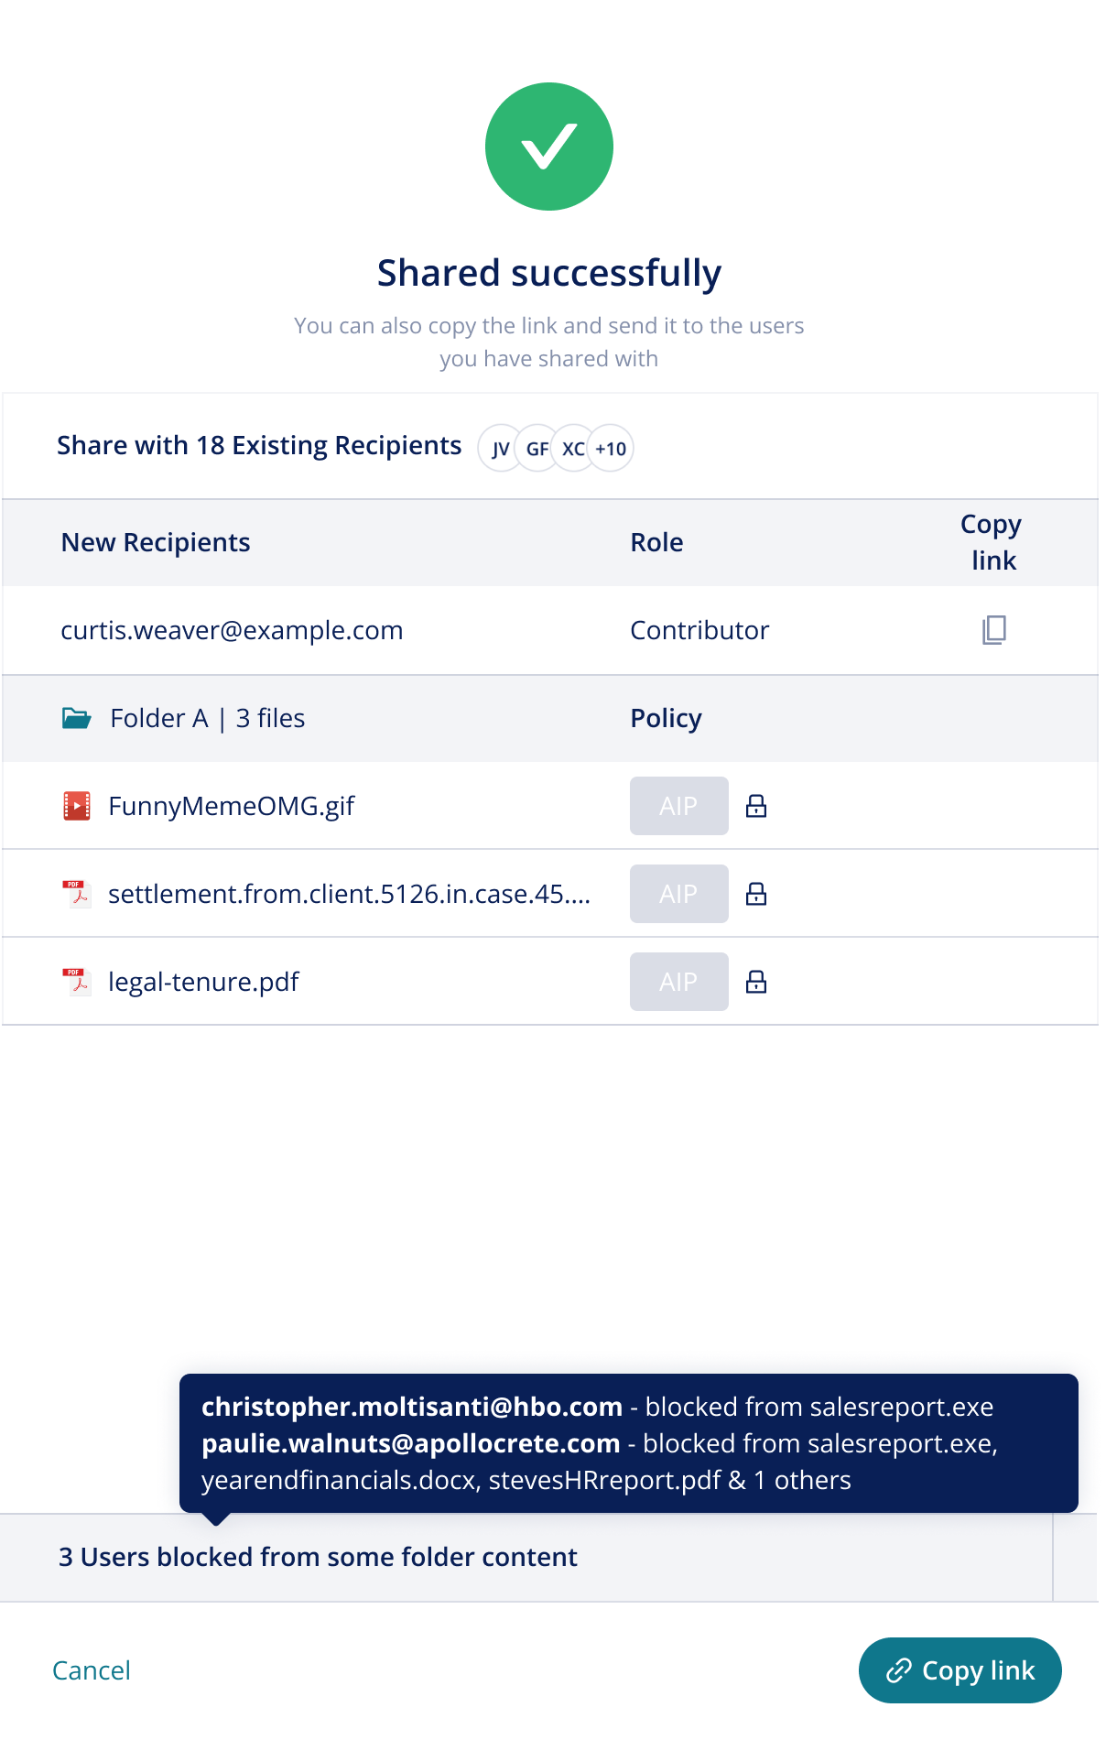

Note:
- Just like when there is no rule impact, existing recipients publish above the new recipients added
- The folder lists each of the files within the folder showing when policy is locked by Rules
- Block results publish in the footer as a summary of the shared state showing:
  - all users that are blocked from some files but have access to some folder contact
  - And new recipients that were attempted to be added in this shared operation but were blocked entirely.
  - This pane does not show recipients that were blocked from the entire folder by a previous share attempt

If new files are added to a folder, the share drawer supports this with the following presentation:

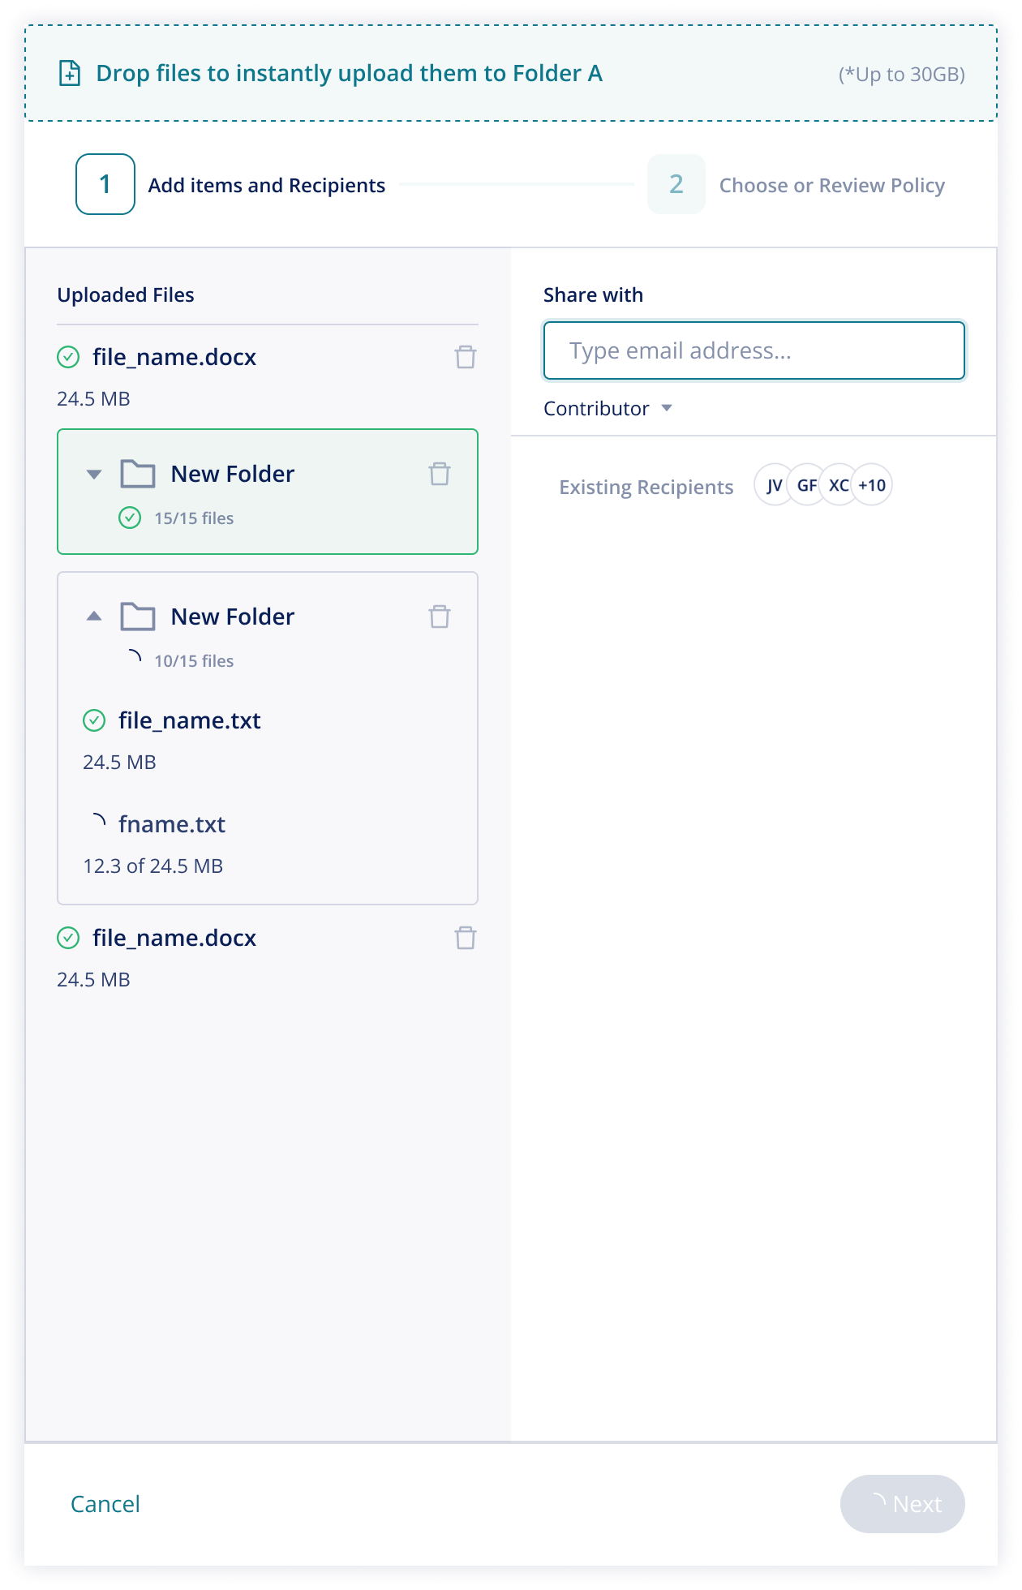

Note:
- When new files are added, draw changes to split pane with uploads on the left and new recipients on the right
- The existing recipients icons are no longer clickable, driving the user to continue the flow once new file shares an initiated.
- Next icon is greyed out and shows load until new uploads are complete - once loaded, the next button becomes clickable

After the user clicks “next” the post evaluation state shows policy and block results that were a result of new files added ONLY as shown below:

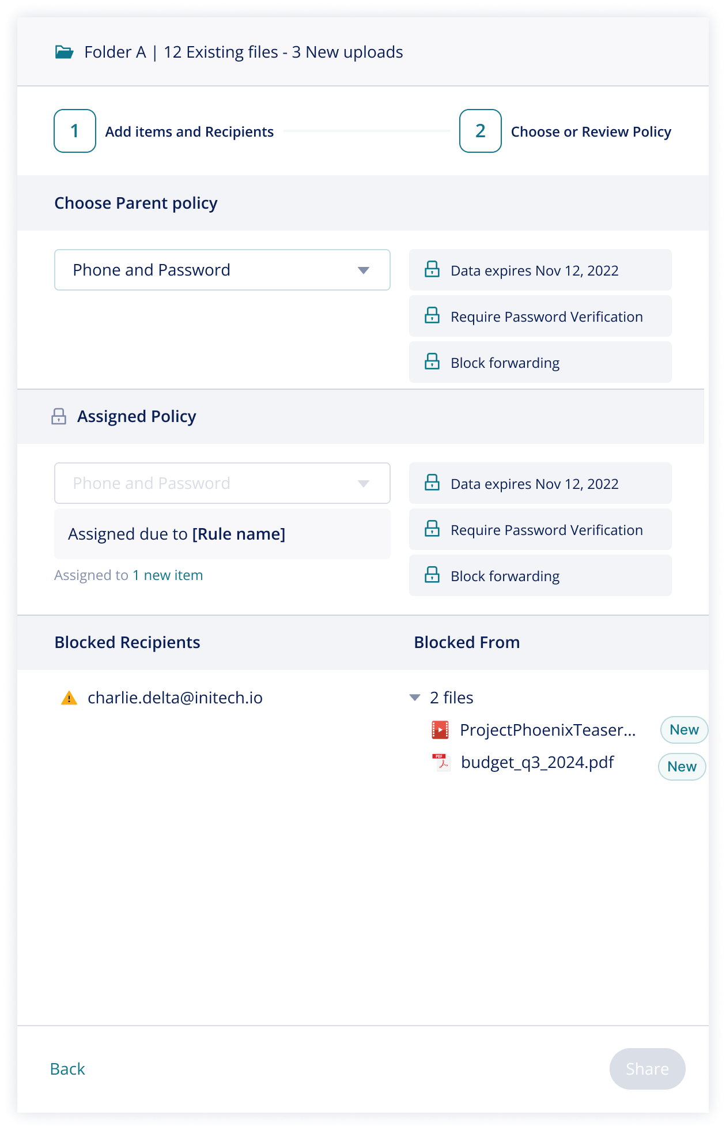

Note:
- The header is no longer a drag and drop field and now the header publishes the folder name and number of files inside and specifying number of newly added files
- Blocked results published as a result of new files added only show block results from the new files added -- not a summary of all block actions across the folder.
- Blocked from all files does not appear when only new files are added to a folder
- If policy was assigned by Rules, it ONLY publishes if that assignment was to NEW files. It does not publish every policy assignment changed or locked by Rules that occurred in the initial upload or result of a previous session change

If the user clicks “share” to complete the addition of the newly added files to the folder, the following “successfully shared” pane is published:

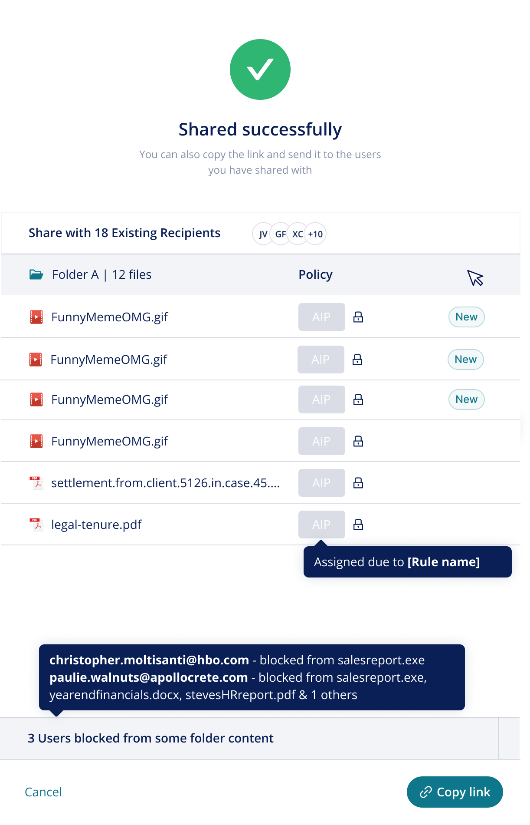

Note:
- Pane presents this as successfully shared with the existing recipient list shown as icons (this clickable to transition to view the permissions pane)
- ALL files within the folder are shown - newly uploaded files added are listed first with “new” label on the right
  - If entire folders were uploaded as subfolders to the existing folder, the subfolder itself is not shown explicitly, it just presents the contents within each by file
- Block results are summarized in the footer showing “some users are blocked from some folder content”
  - This footer lists each user individually with the files they are blocked from – showing all recipients that have partial access to the folder.
  - If the list is too long to be shown in the pop-up, the pop-up show “Some users have been blocked from some or all files by organizational rules. Please review audit logs to see all system actions taken”

Supporting BOTH new files and new recipients added to a folder

As a data owner may initiate both new files and new recipients added to a folder, UI must accommodate these flows that operate from the existing logic of each individual actions and support slight accommodations for these actions taken together in the following flows:

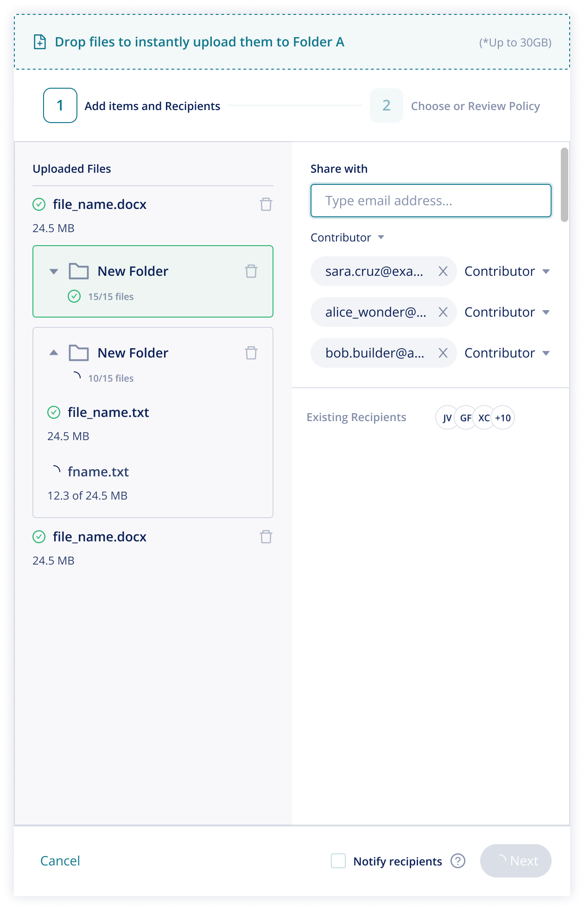
Note:
- When new files and new recipients are added simultaneously, the checkbox to notify new recipients publishes – note that this is to notify new recipients NOT to notify all recipients of new file additions

If Rules are triggered, actions show only that which has been triggered by the actions of this drawer session as shown below:

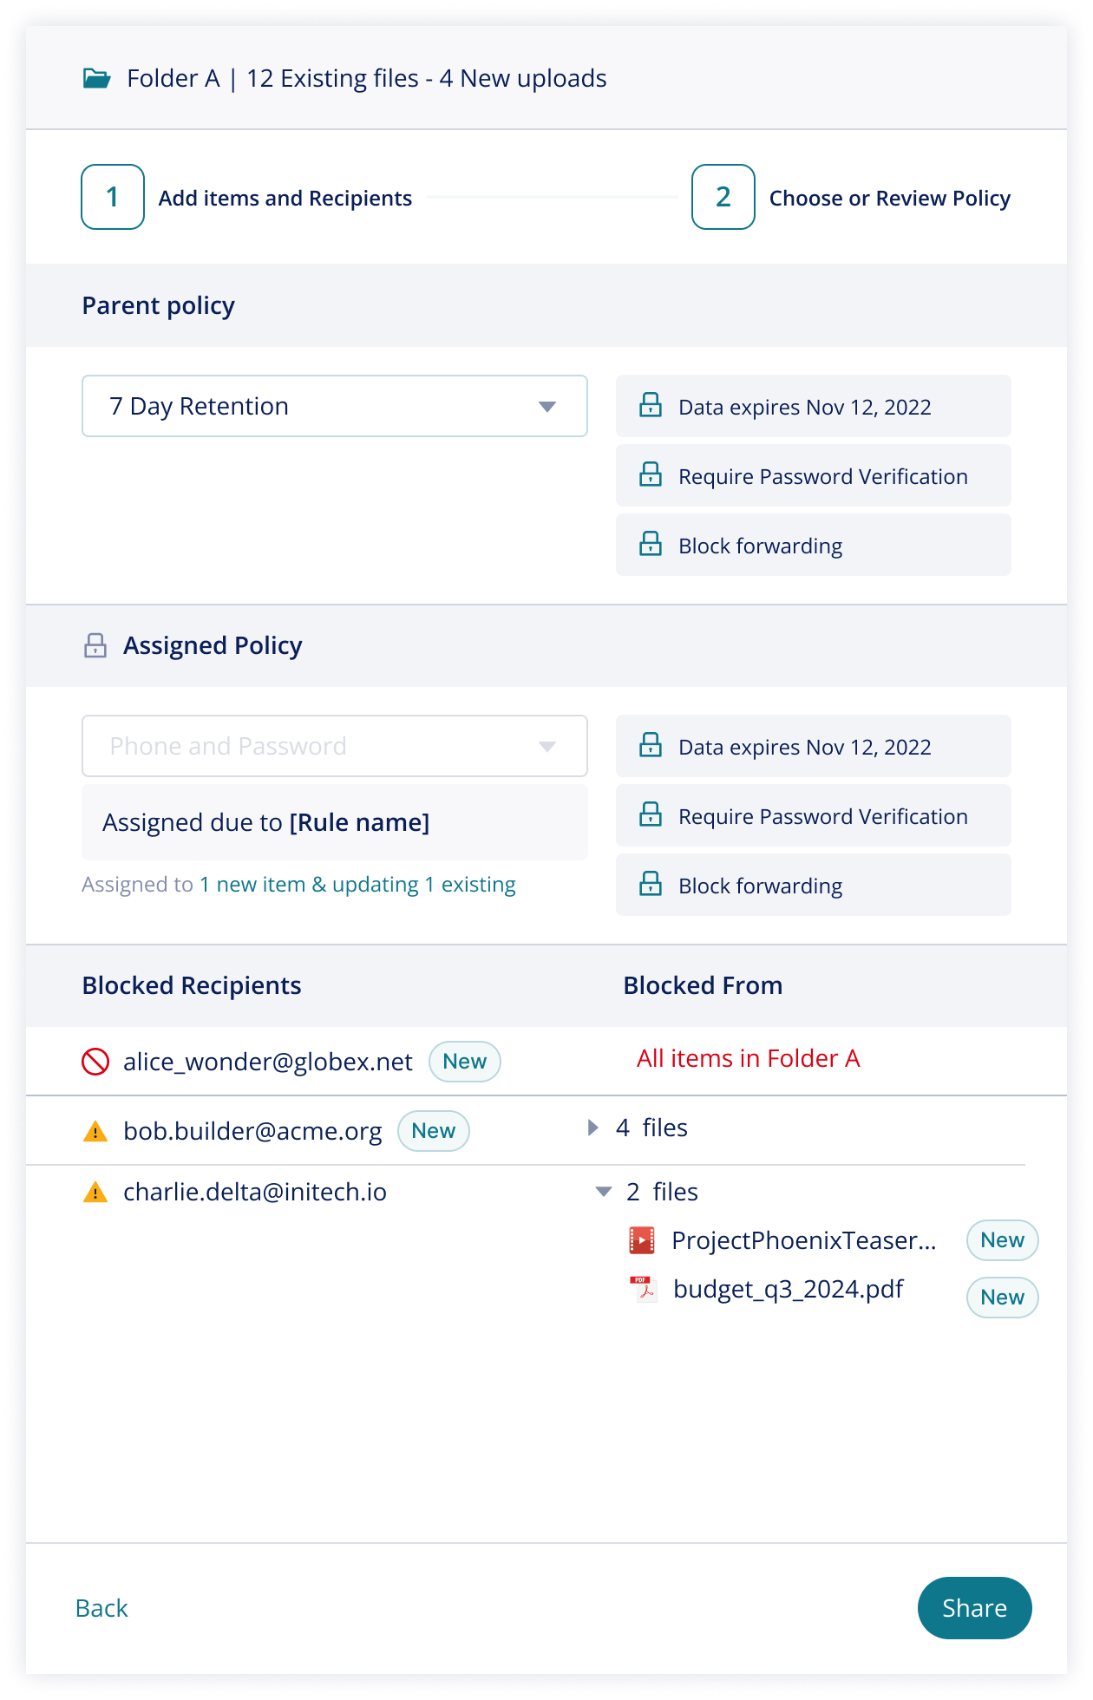

Note:
- Policy assignment by rules only publish if it triggered by a new file or a new assignment to an existing file
  - The text below the rule states “1 new file & updating 1 existing” to allow the user to understand this - this also operates as a tool tip like standard drawer behavior
- Block results use “new labels” to show new recipients blocked and new files blocked
  - Blocked recipients ONLY publish if they were affected by actions of this session:
    - meaning if an existing user had partial access BUT the actions of this session did not prompt additional block results then the blocked status for this user doesn’t show here.
  - This allows the user to understand if it was an existing user who is blocked from new files or a new user blocked from existing or new files
- The user can only progress from this pane if at least one new recipient is not entirely blocked or 1 new file was not blocked from at least 1 existing recipient

If new files and new recipients are added to a folder and the share is completed, the “successfully shared pane” presents following the existing logic of this ticket:

- Existing recipients are shown with icons
- New recipients are individually listed
- All files within the folder are listed - newly added listed first with New label
- Blocked results shows all users with partial access AND NEW users FROM THIS SESSION that were entirely blocked from the folder

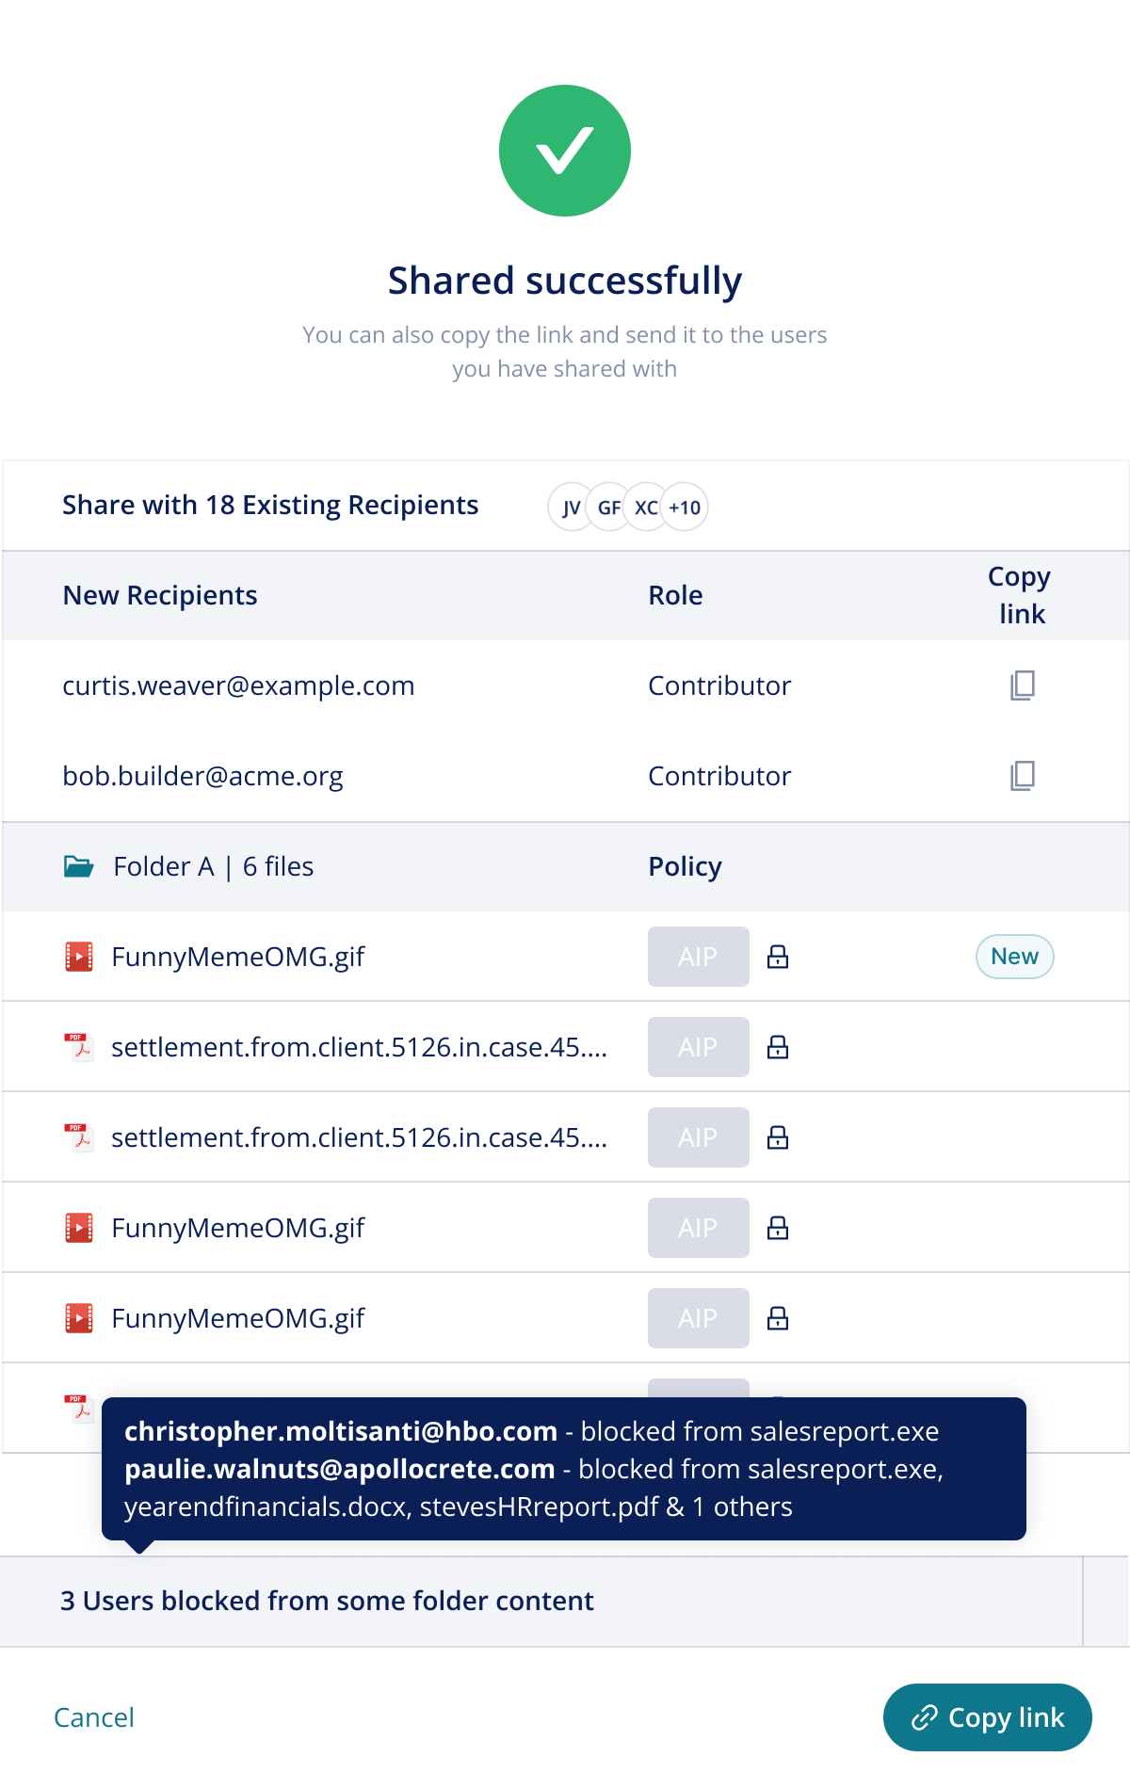

Support Sharing of Multiple Files or Folders from My Files View

Goal: Support Rule evaluation when multiple existing files and/or folders are selected to re-share through the My Files homepage.

Description: This flow is supported by our platform and must be adapted for rule evaluation through the share drawer. This flow should allow the user to share multiple items under their existing policy assignment UNLESS rules are triggered which prompt change. This flow should follow the existing principles of all modification flows outlined with V20 changes.

Notes on changes from existing behavior: The platform currently supports this however there are bugs which make it seem that all files selected together must be shared under one policy (rather than maintaining the existing) but don’t enforce the policy change post share.

Definition of done:
- Mocks are created for the core flow and significant behavior variations:
  - Many files with the same existing policy are shared together
  - Many files with different policies selected together
  - Files and folders selected to be shared together
- Files/folders selected to be shared show the existing policy assignment and do not prompt for singular assignment for all shared items
- Block results in the post evaluation and policy pane only show those that were triggered by the current session
- Block results in the "successfully shared” post share message pane only show those relevant to this session – (only new recipients blocked)

Out of scope:
- This flow does not support the addition of new files to folders in addition to new recipients in these flows

